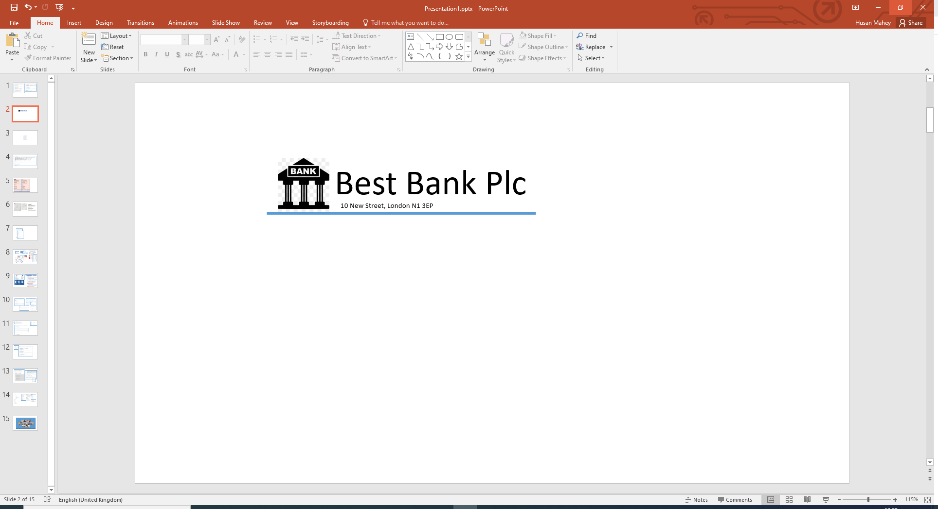

Mrs Vannessa Casper

45 Bradfield St

Newquay

Cornwall

TR7 1LS

Our Ref: Q299

Dear Vannessa,

Congratulations! Based on the information provided by you, we are pleased to inform you that you have been pre-approved for your recent loan application.

**Loan Details**

Amount: £ 3,500.00

Term: 12 months

Interest Rate (APR): 8.50%

Total Payable: £ 3,657.12

Monthly Payment: £ 304.76